

Nugent

CQ3000.



Euroby Ltd

Phil Benn

Site Report for
Nugent.

Sittingbourne.

This document was written by: Name Karl Alnwick Date April 25
Position Service Engineer

This document version was updated by: Name Phil Benn Date April 25
Position Service Manager

This document version was reviewed by: Name Date
Position

This document version was approved by: Name XXXXXXXXXXXX Date XXXXXXXXXX
Position XXXXXXXXXXXXXXXXXXXXXXXXXXXXX

Rev | Issue Date | Doc ID | Position | Section Changes
A | Apil 25 | DSS KA 001 | First Issue
B | April 25 | DSS PB 002 | Second Issue
C |  |  | Third Issue

Table of Contents
1. Strip 3
2. Issues Noted 3
2.1 Wet end 3
2.2 Dry end 4
2.3 Scroll removed 6
3. Options. 7
3.1 Option 1. 7
3.2 Option 2. 7
3.3 Option 3. 8

1. Strip

Euroby engineer stripped the machine to component parts.
Taking close notice and photos of the current build along the way.

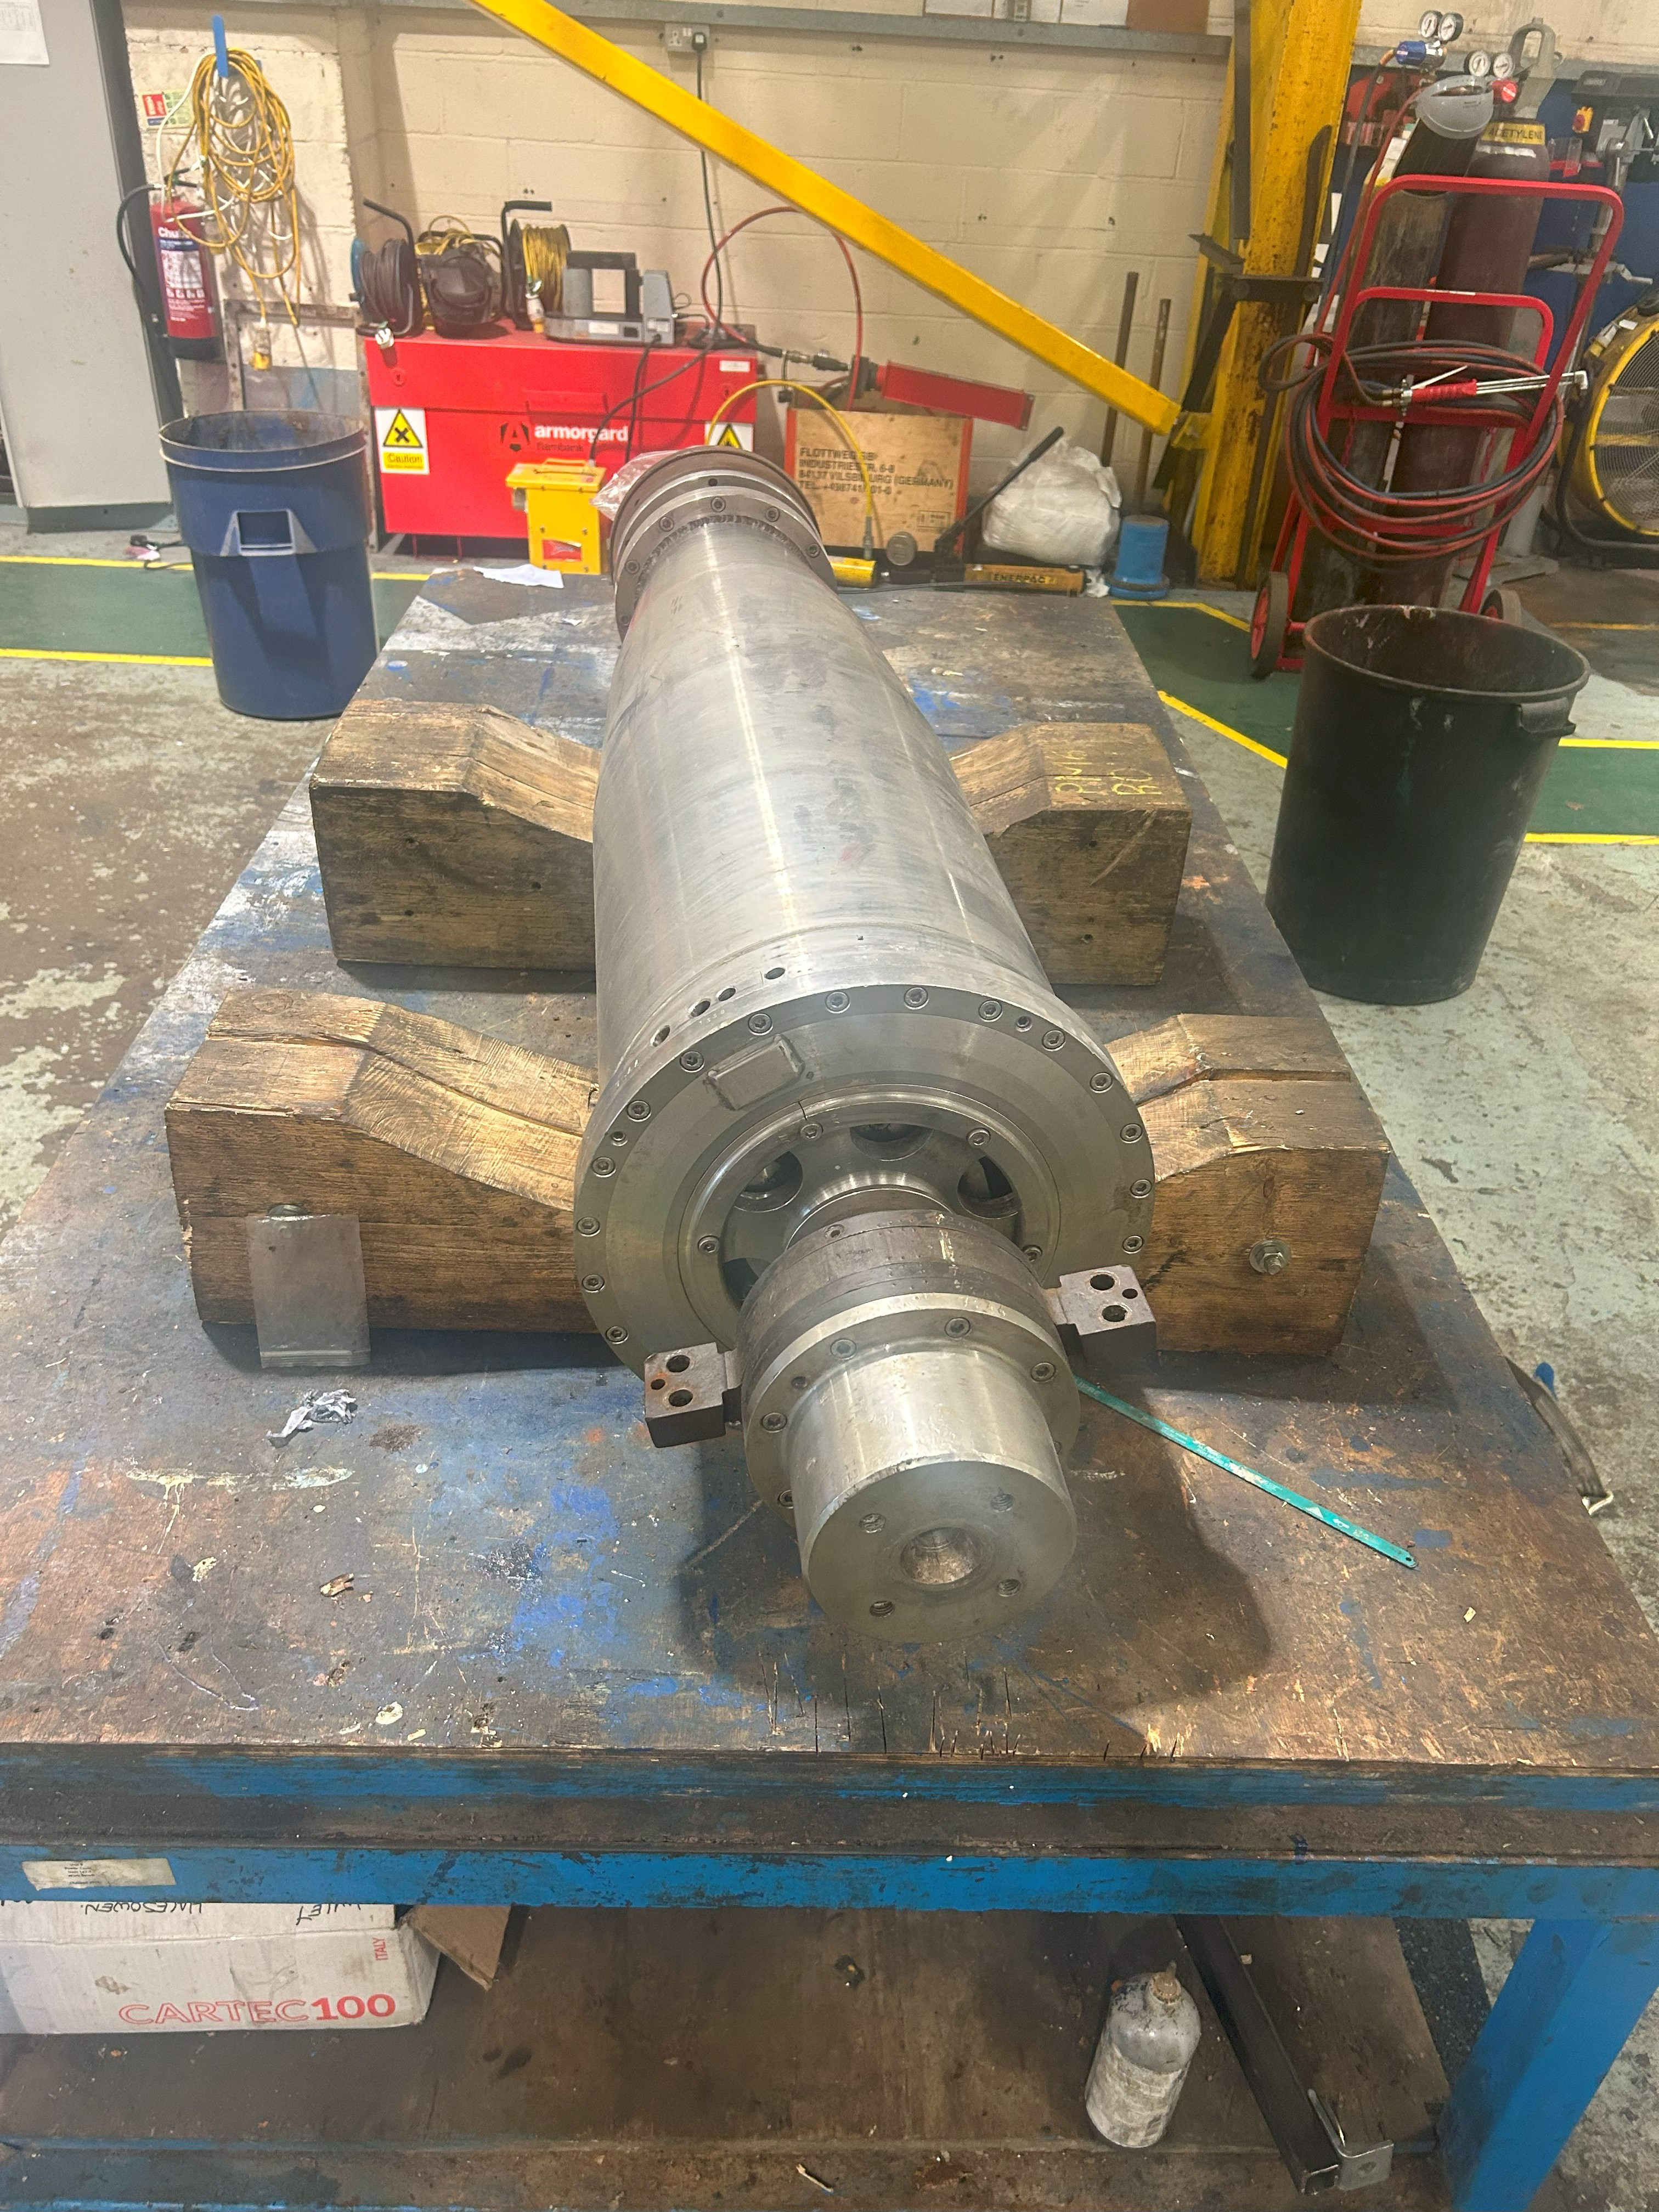

2. Issues Noted

2.1 Wet end

It was noted prior to starting work that the datum marking on the wet end was not aligned correctly as per the photo below.
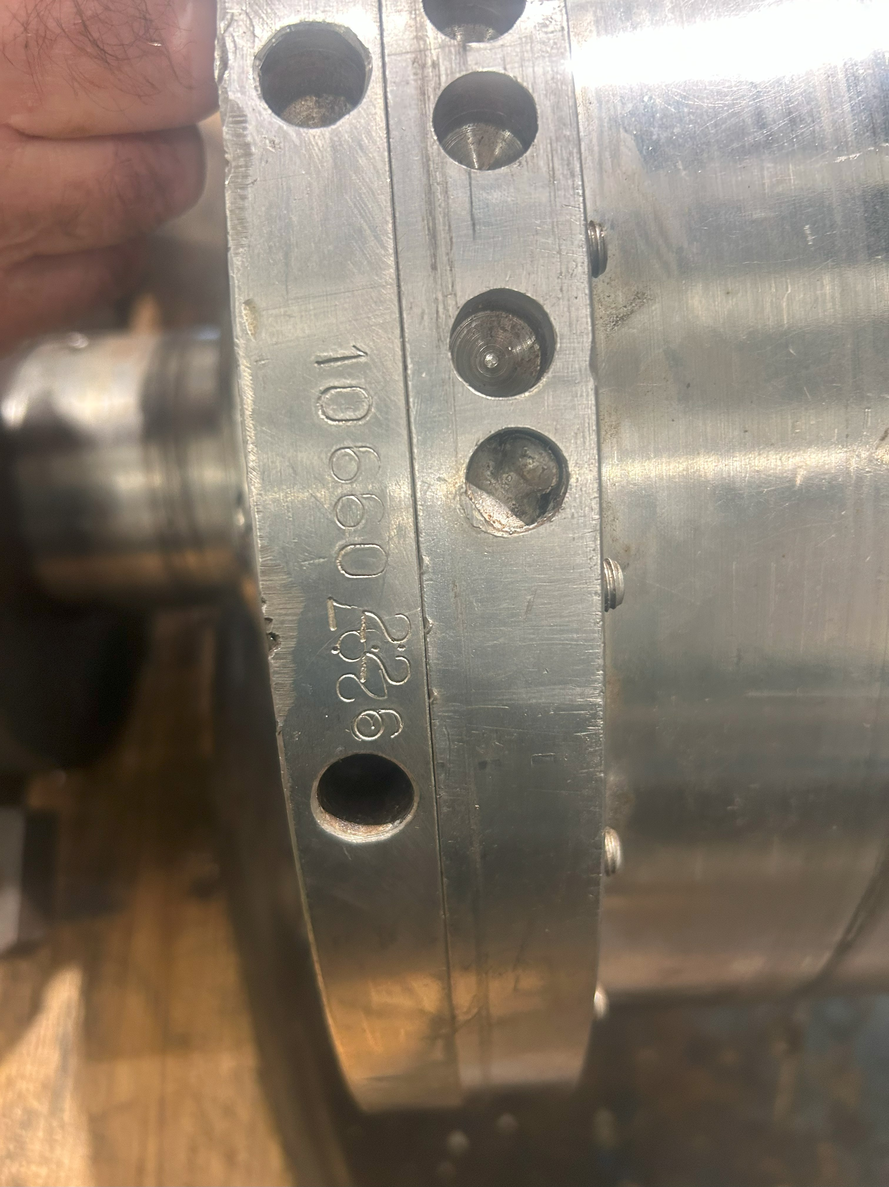

When building up this equipment, the standard alignment should be serial number to serial number where whereas in the photo is shows this was not done correctly.
There were, however, multiple other markings all around the outer faces where this had been stripped and rebuilt over time incorrectly.

2.2 Dry end

It was noted that some of the port liners were damaged as per the photo below.

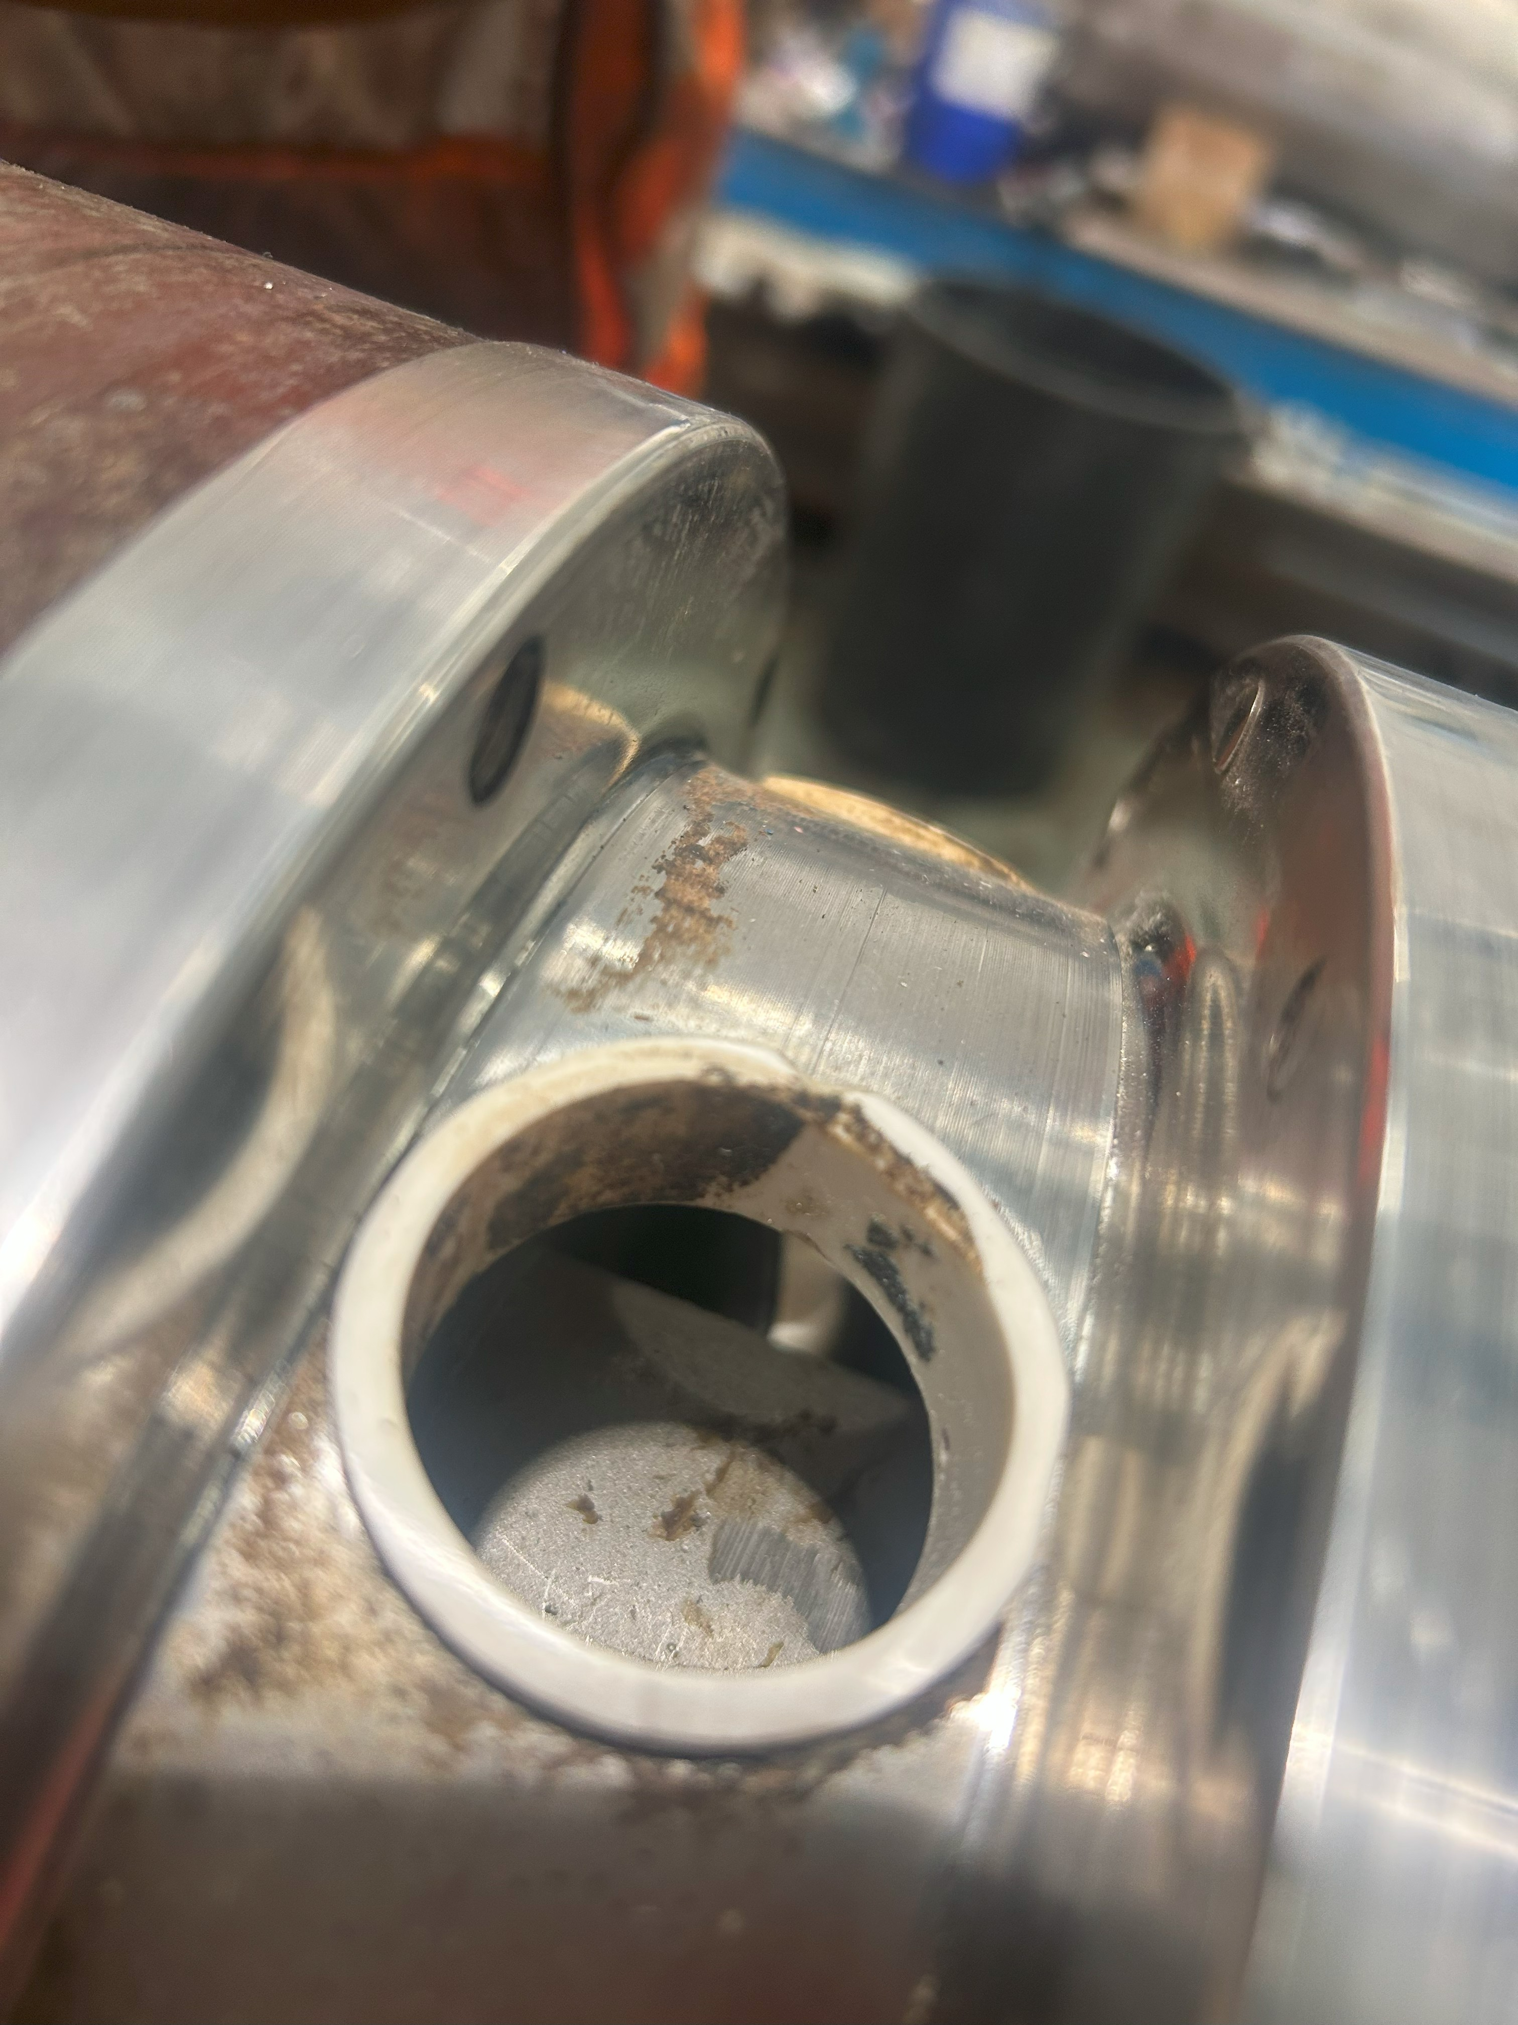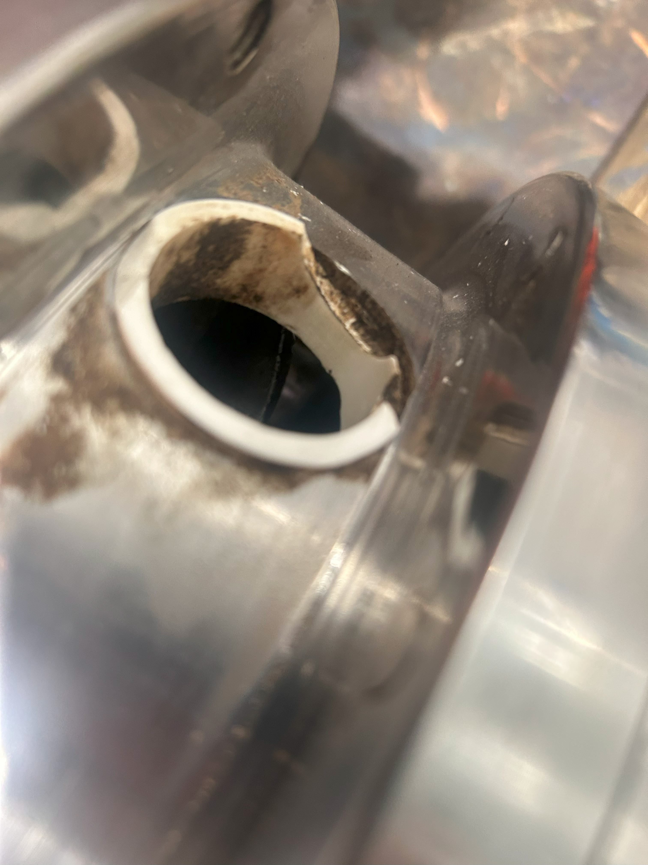

When disassembling the unit, it was noted that the seal on the inner face of the Feed end bearing housing was missing the top half this is simply superficial as it would only lead to minimal seeping when flushing the machine and could have happened when removing the rotating assembly.
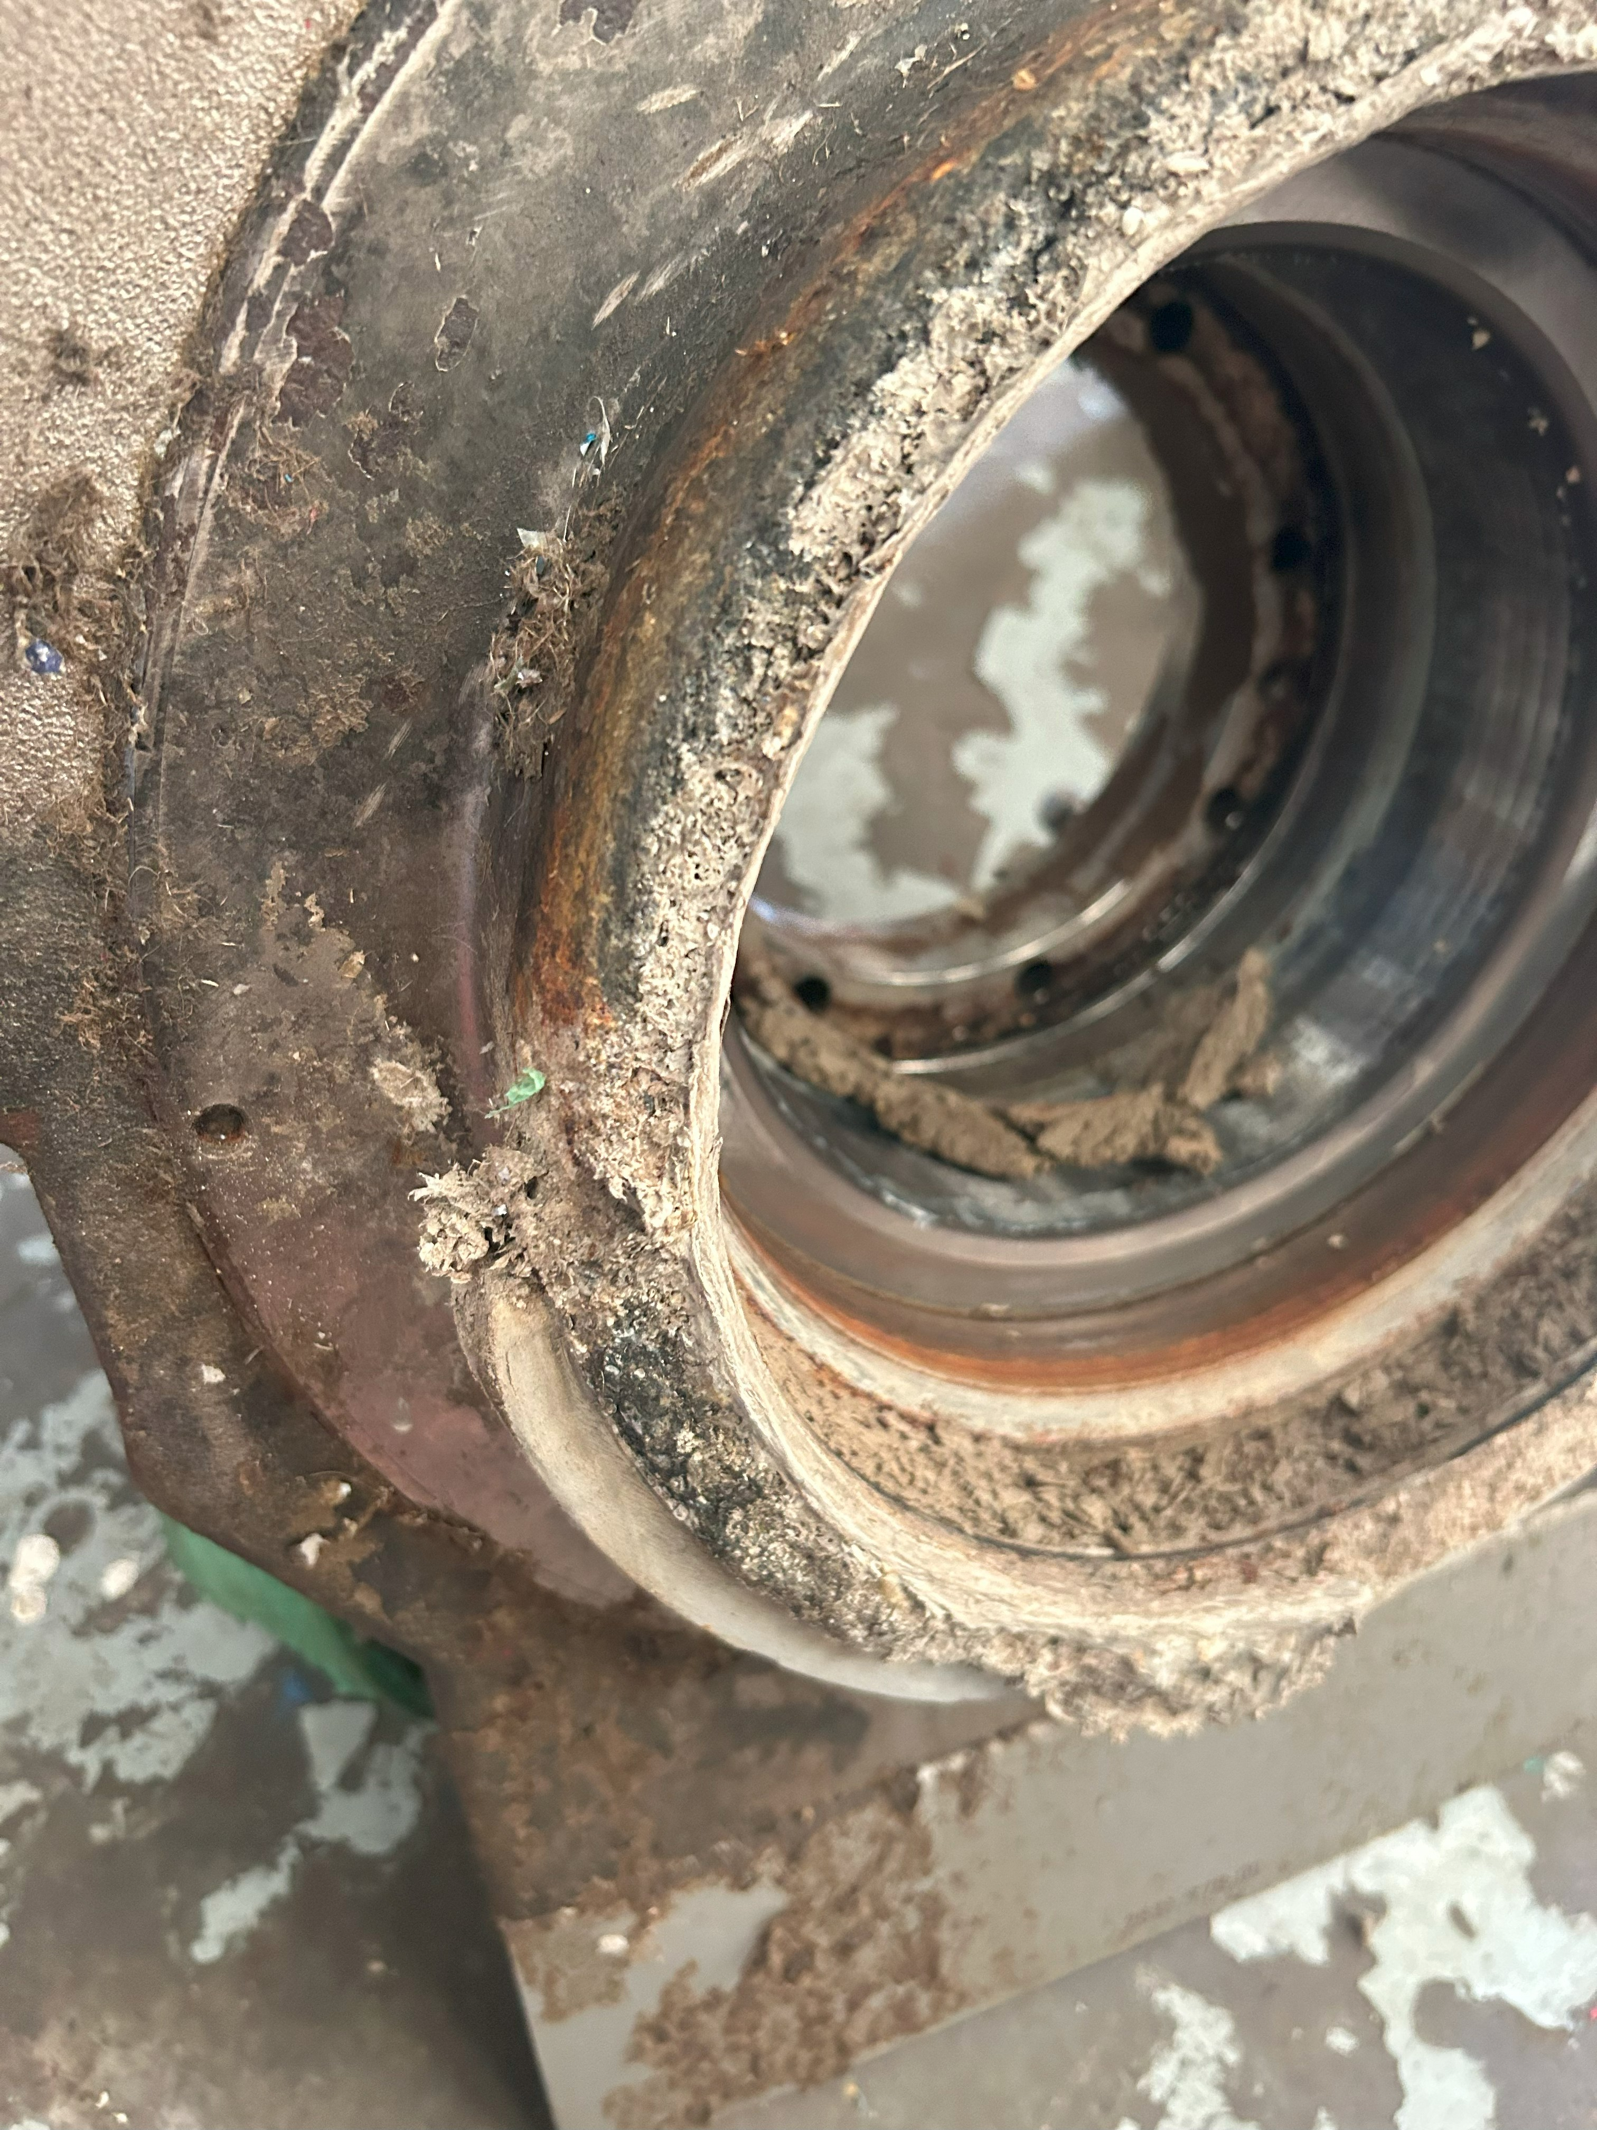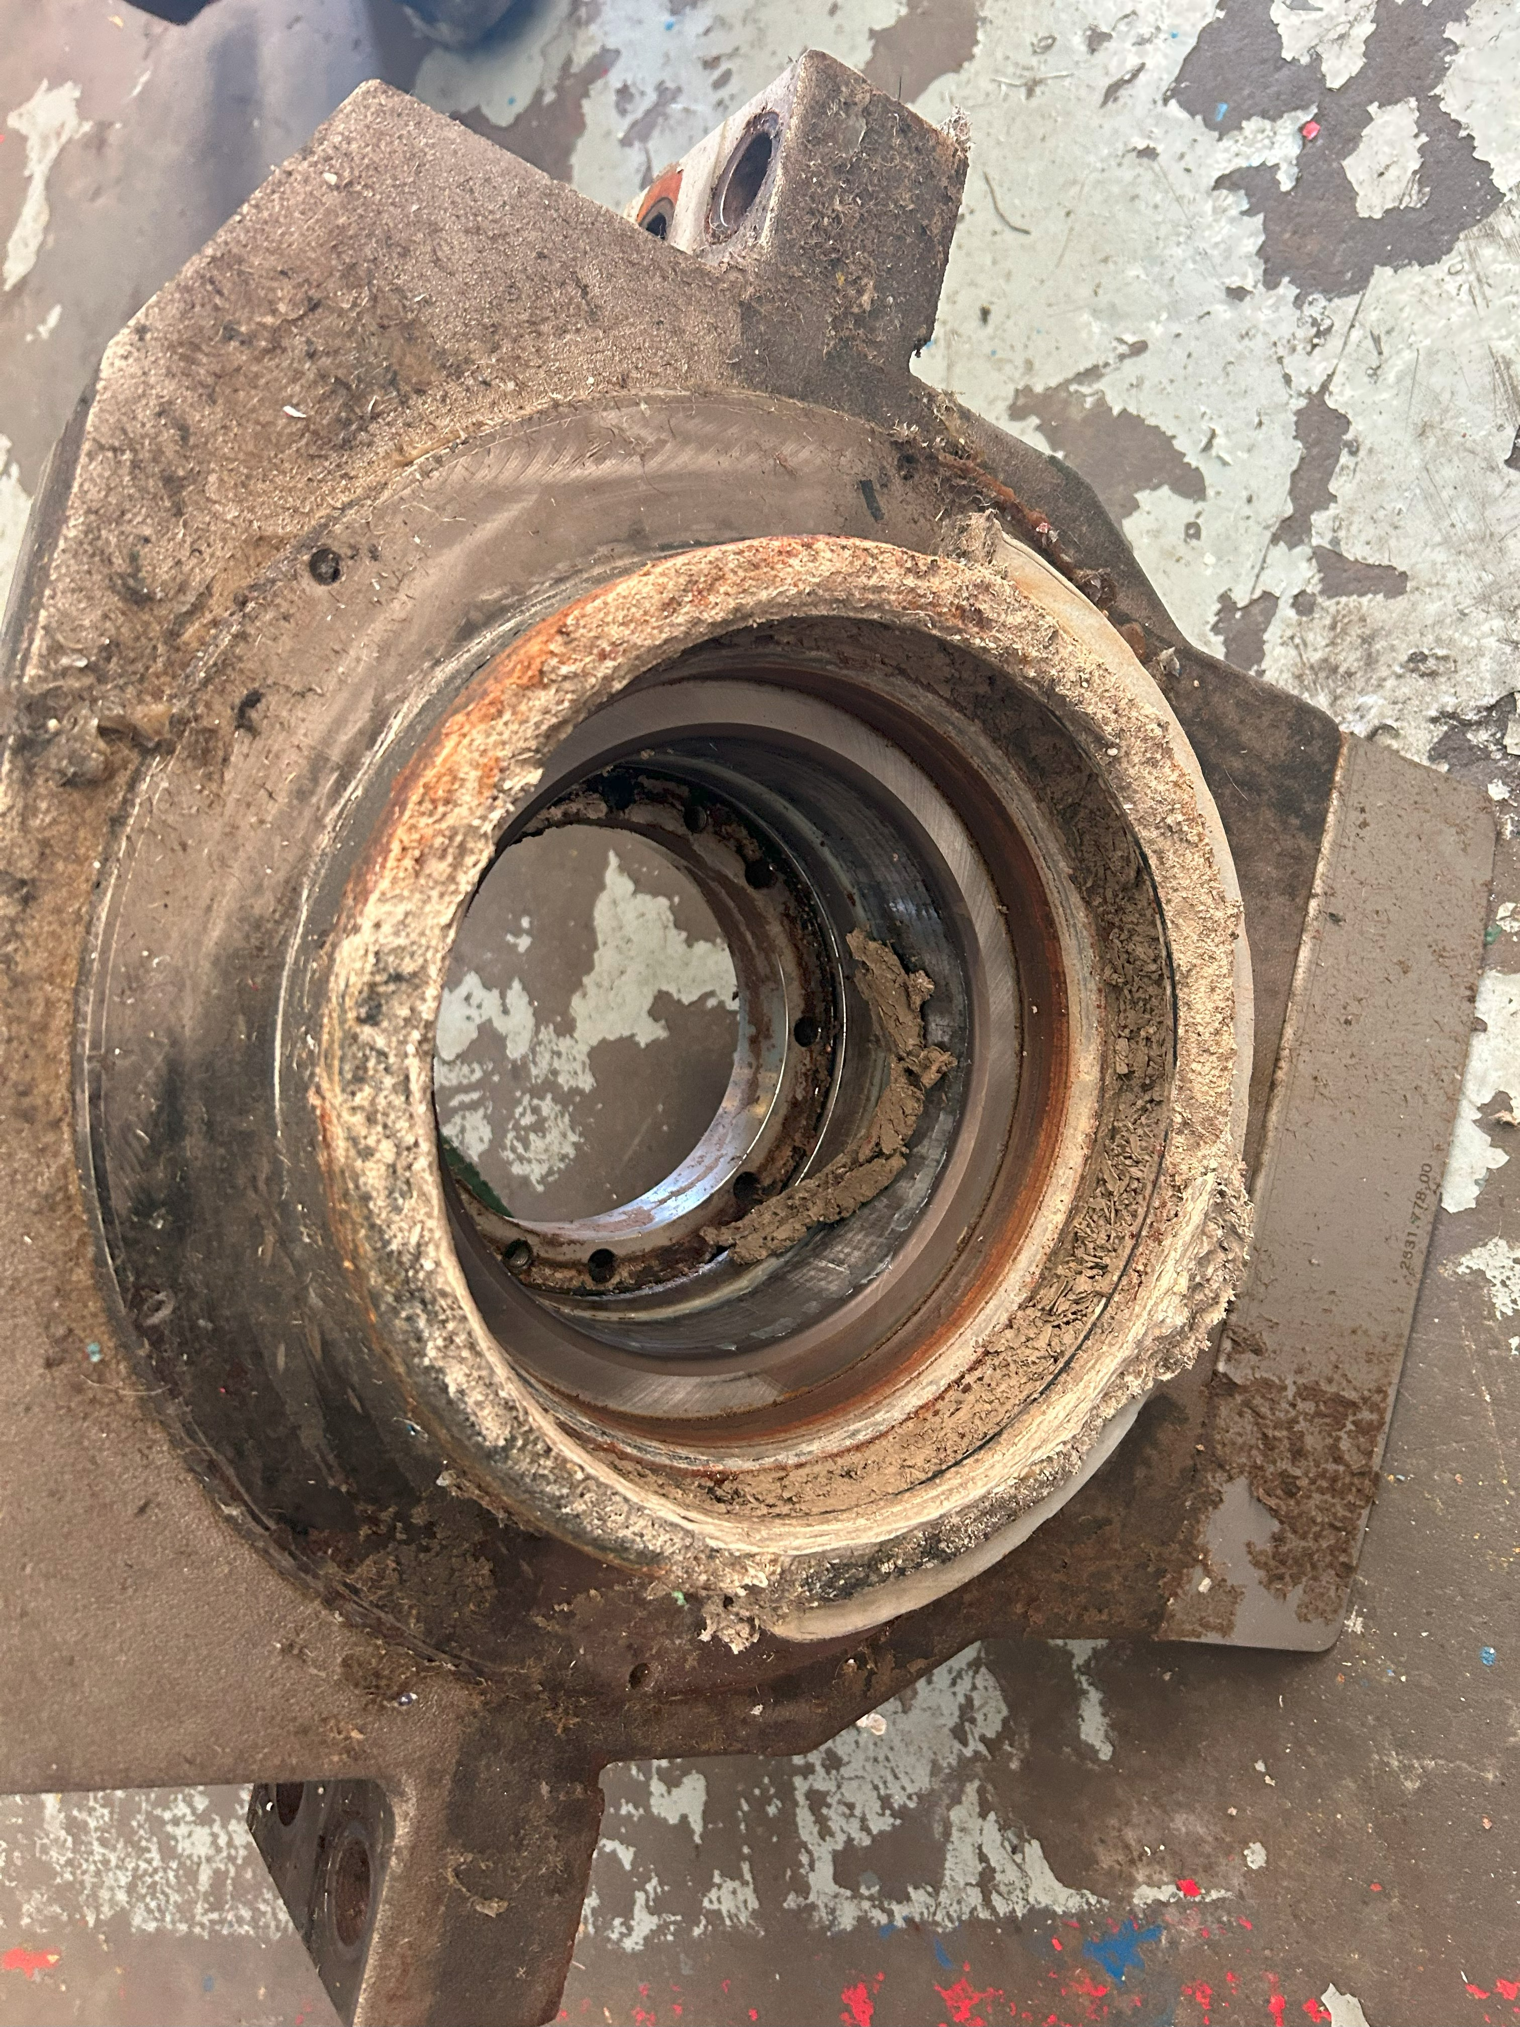

The rotodif was removed and inspected but not tested due to not having the hydraulic power pack available.

Once again, poor alignment was noted at the wet end, with the cover not fitted on the markings as per the photo below.

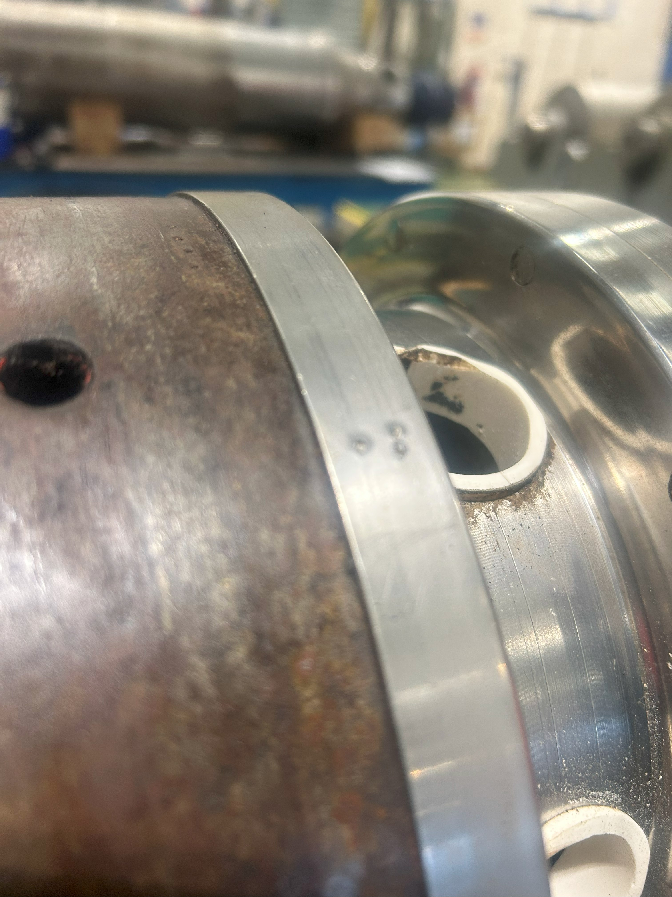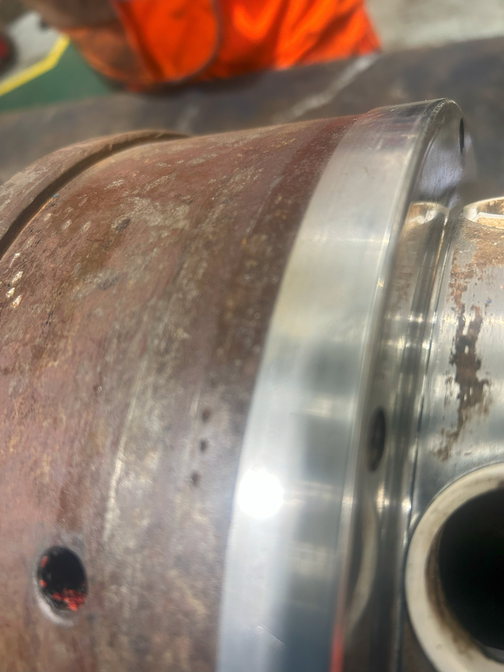

2.3 Scroll removed

The scroll was removed, and noted that there was wear to the hard facing on the edge of the flights as per photo below.

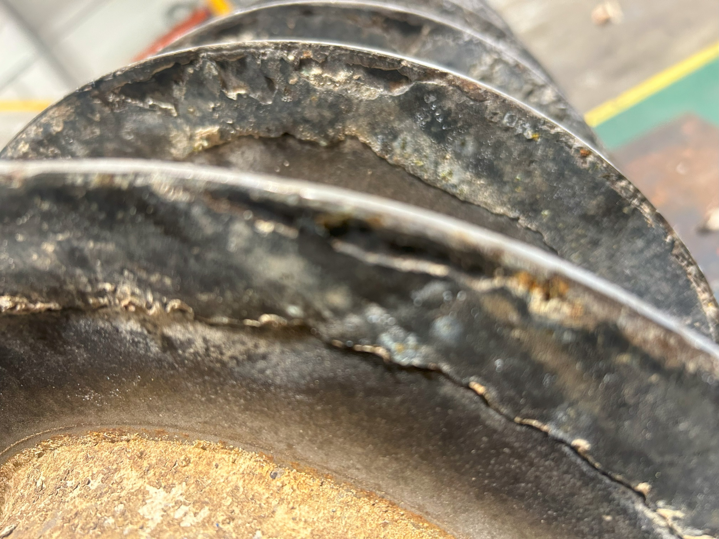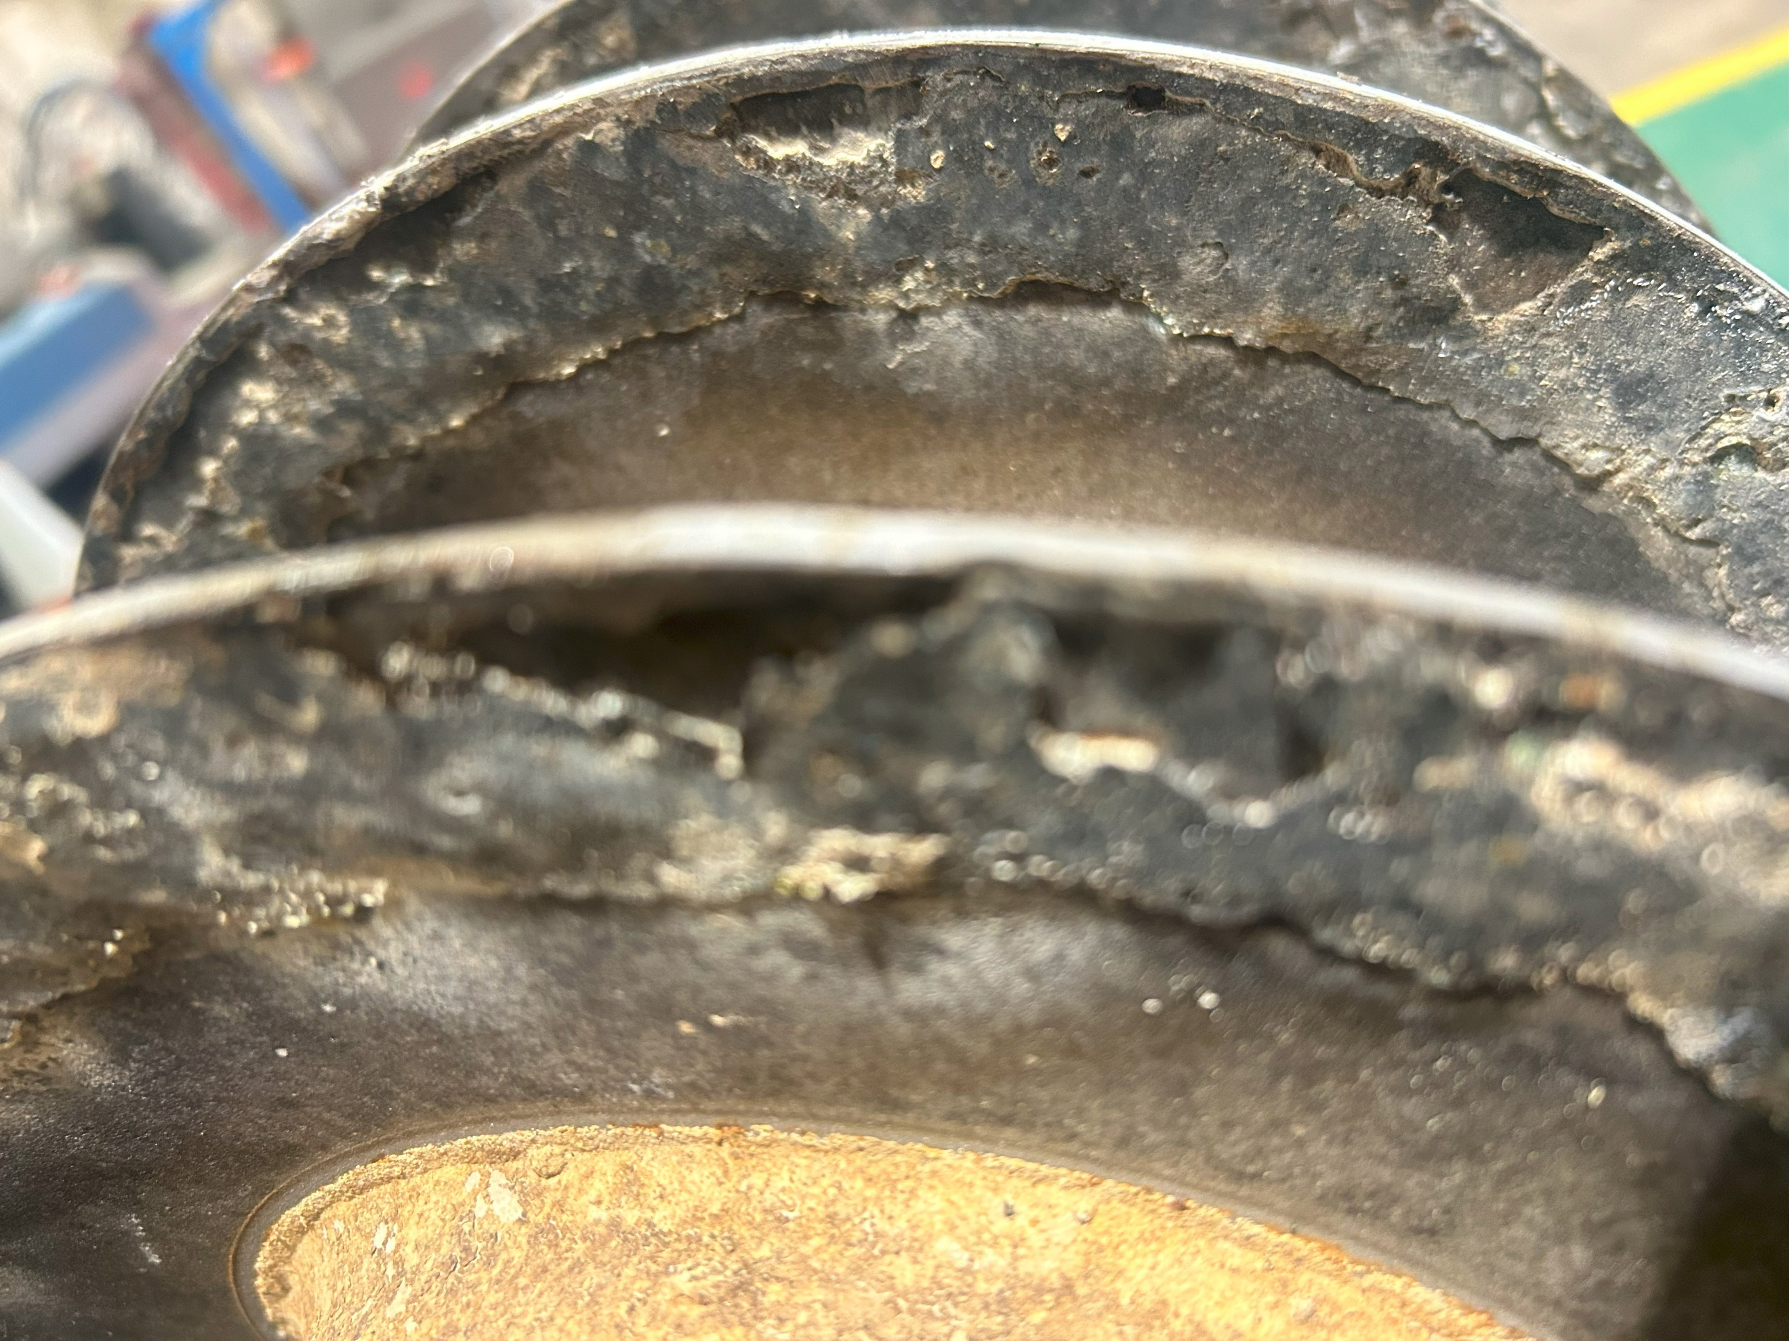

Also it was noted that the ceramic wear insert inside the scroll had been incorrectly fitted ad was not aligned properly.

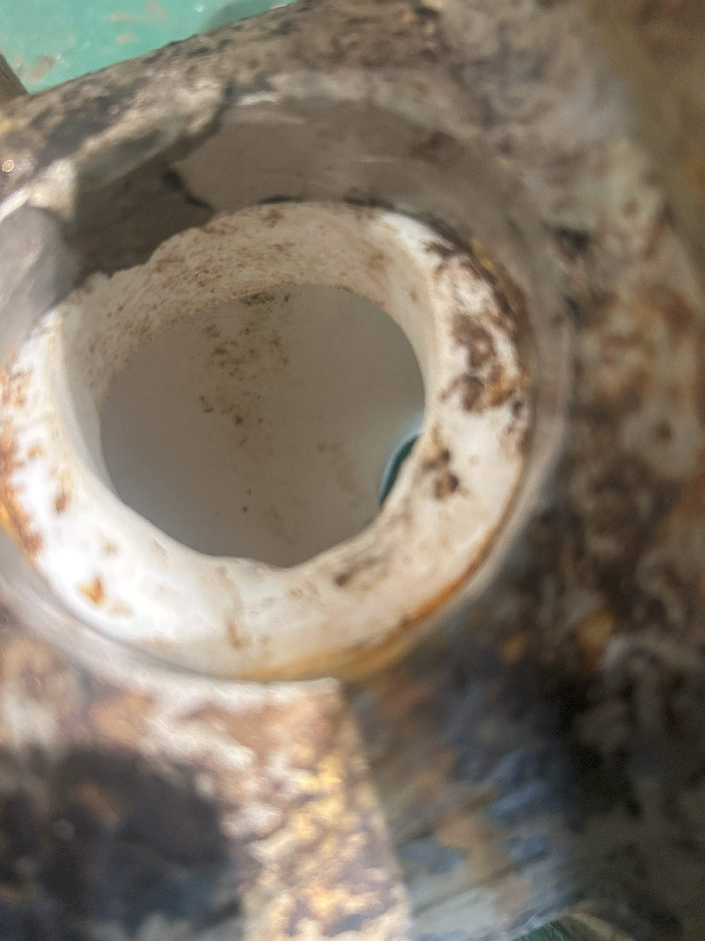

Once removed the wear strips within the bowl body were inspected and it was noted that a few parts were well worn.

3. Options.

3.1 Option 1.

The minimum work required would be to refit the components in the correct orientation on the correct datum marks, polish off the incorrect markings and have the bowl and scroll checked for balancing.
Rebuild using an all-new service kit.

3.2 Option 2.

The minimum work detailed within option 1, plus replacing the ceramic bushes in both the bowl and scroll. Have the flights of the scroll's recoated faces to avoid any further wear, as without this, wear will be much faster.

3.3 Option 3.

Of a higher cost, but the option to replace the machine due to its age and the fact that it is no longer a manufacturer-supported machine. If a replacement machine were installed, it would have better control and should produce better results, as the technology has greatly improved since the manufacture of the current unit.

